How to install MYSQL
The way to install MySQL as following:
1. Double-click your mouse on application you want to install.
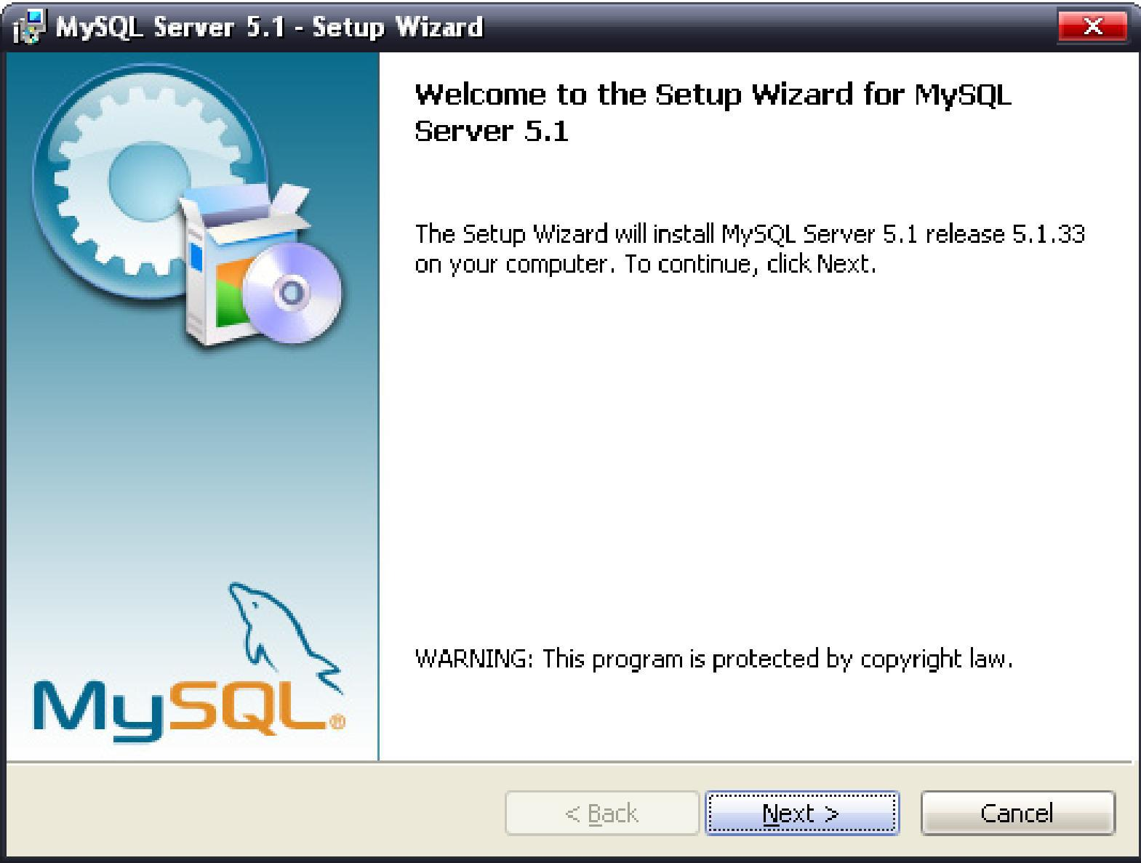

2. Click “”to go to next step as following picture.
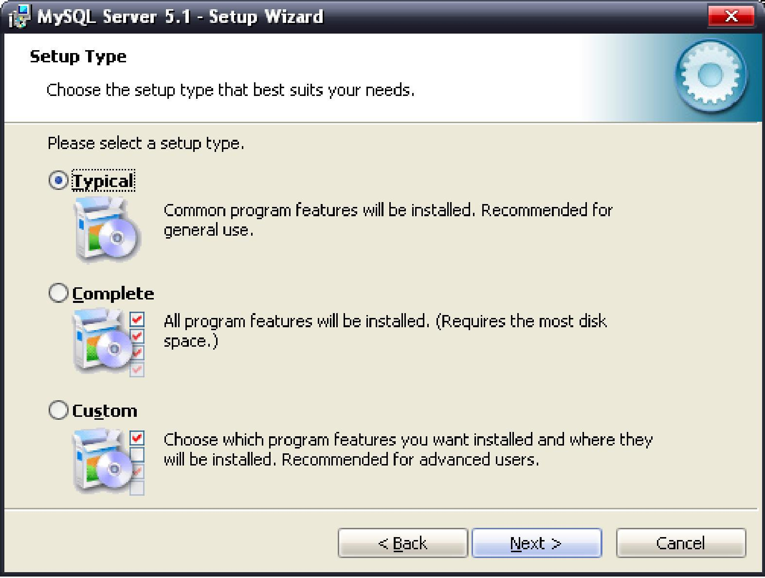
3. Select “Typical’ and click “’
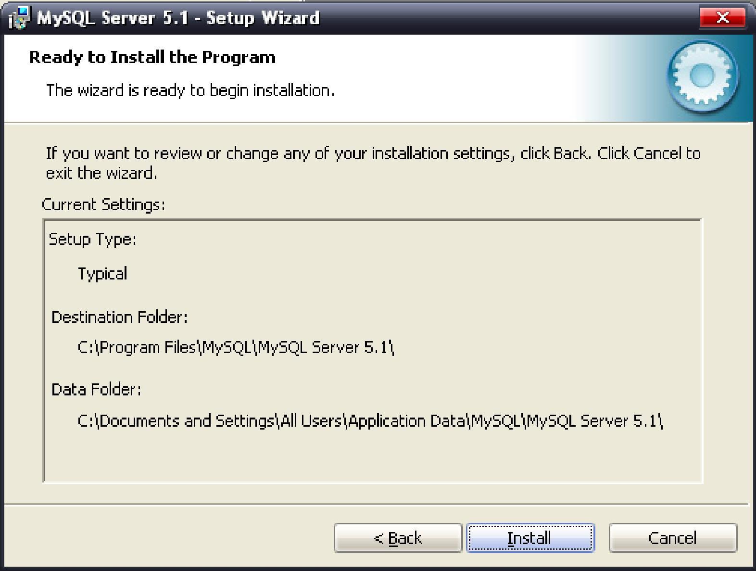
4. Click “Install” to start installation
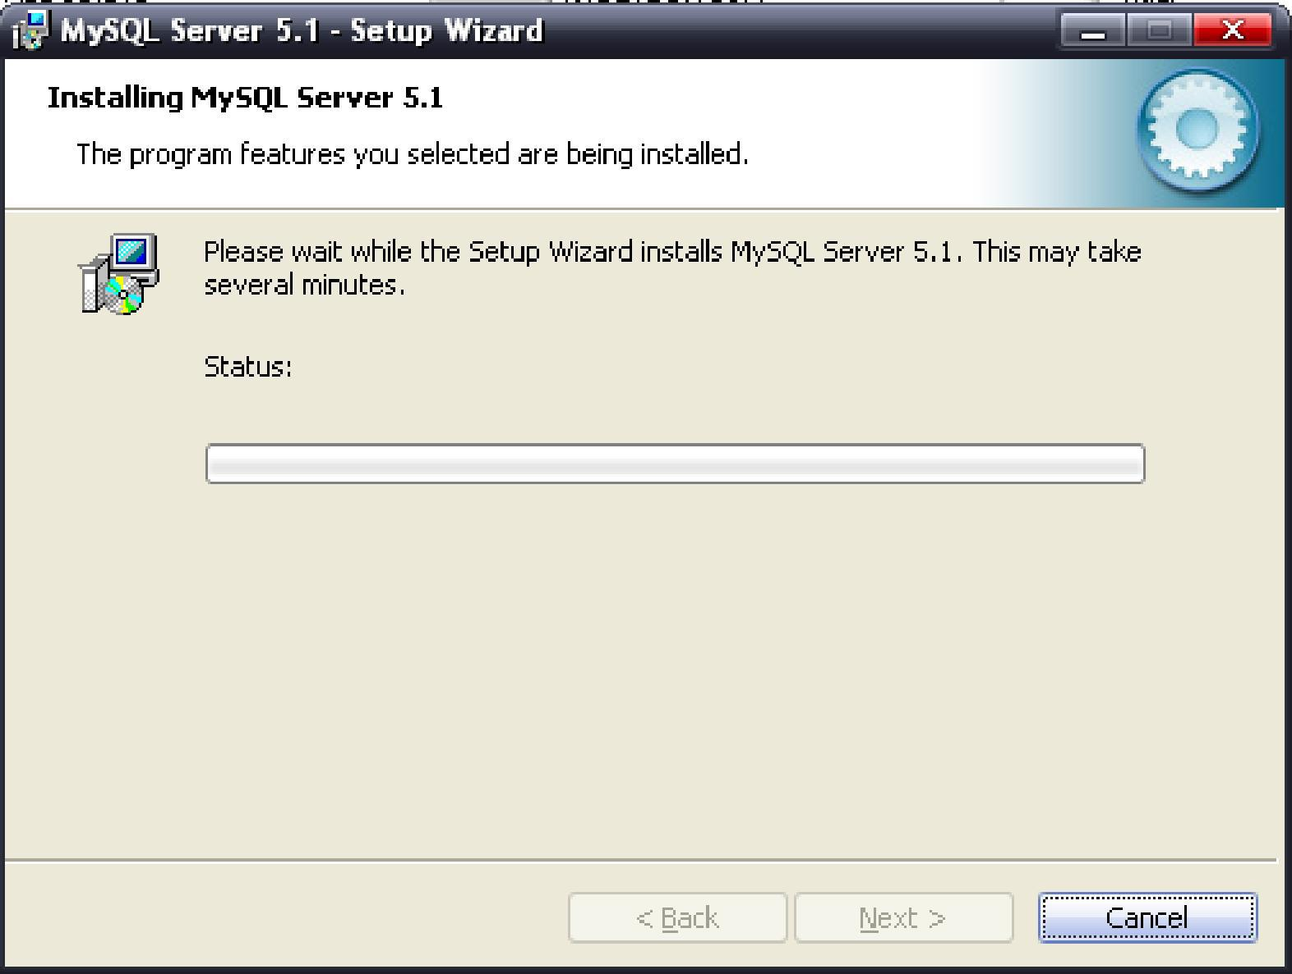
5. After installation, there will be an interface which introduces MySQL in brief.

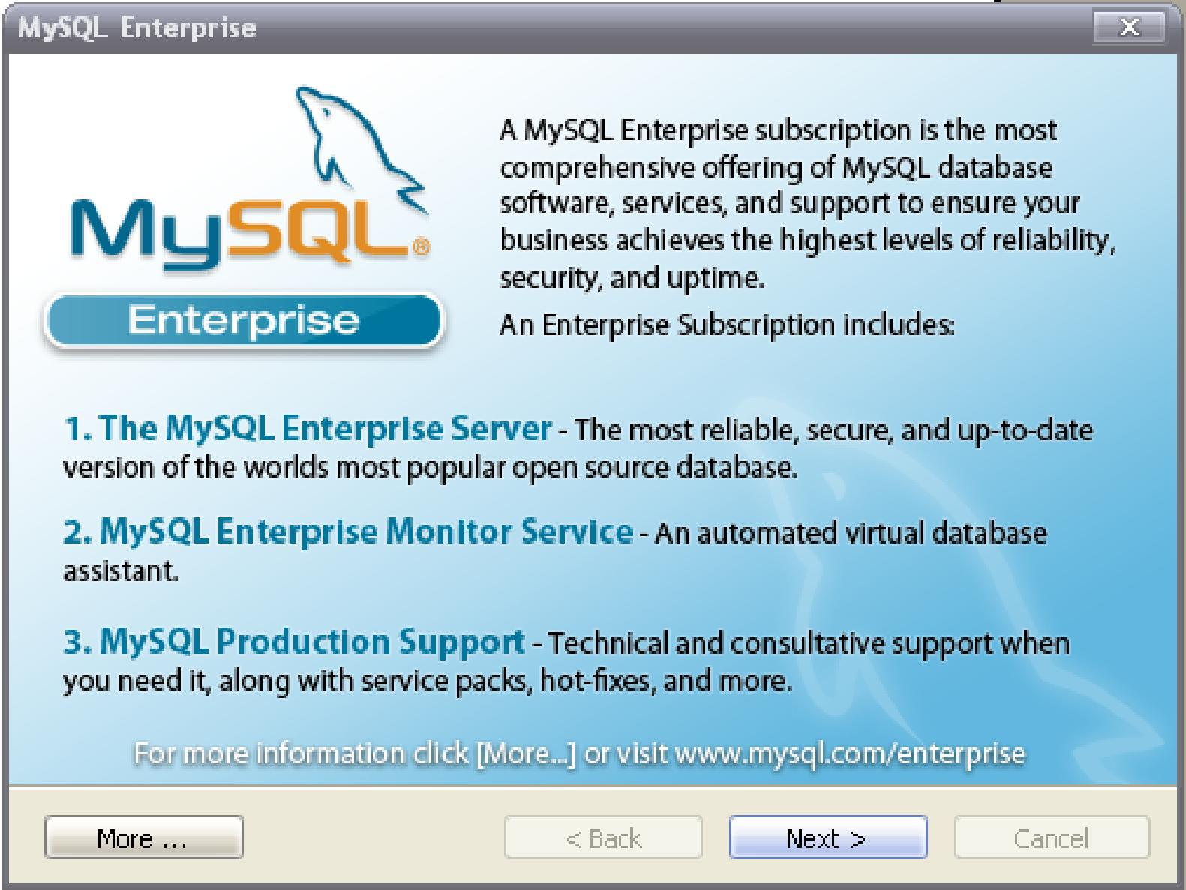
6. Click “”to go to next step as following.
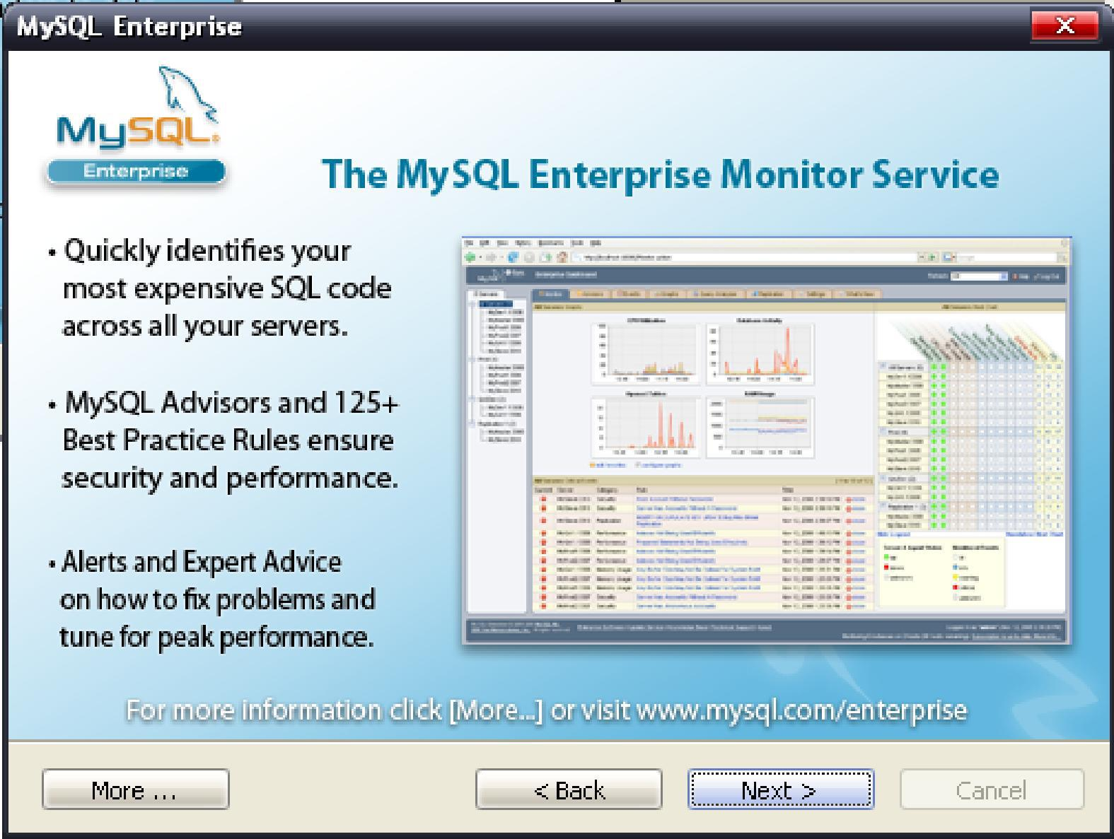
7. Click “”again

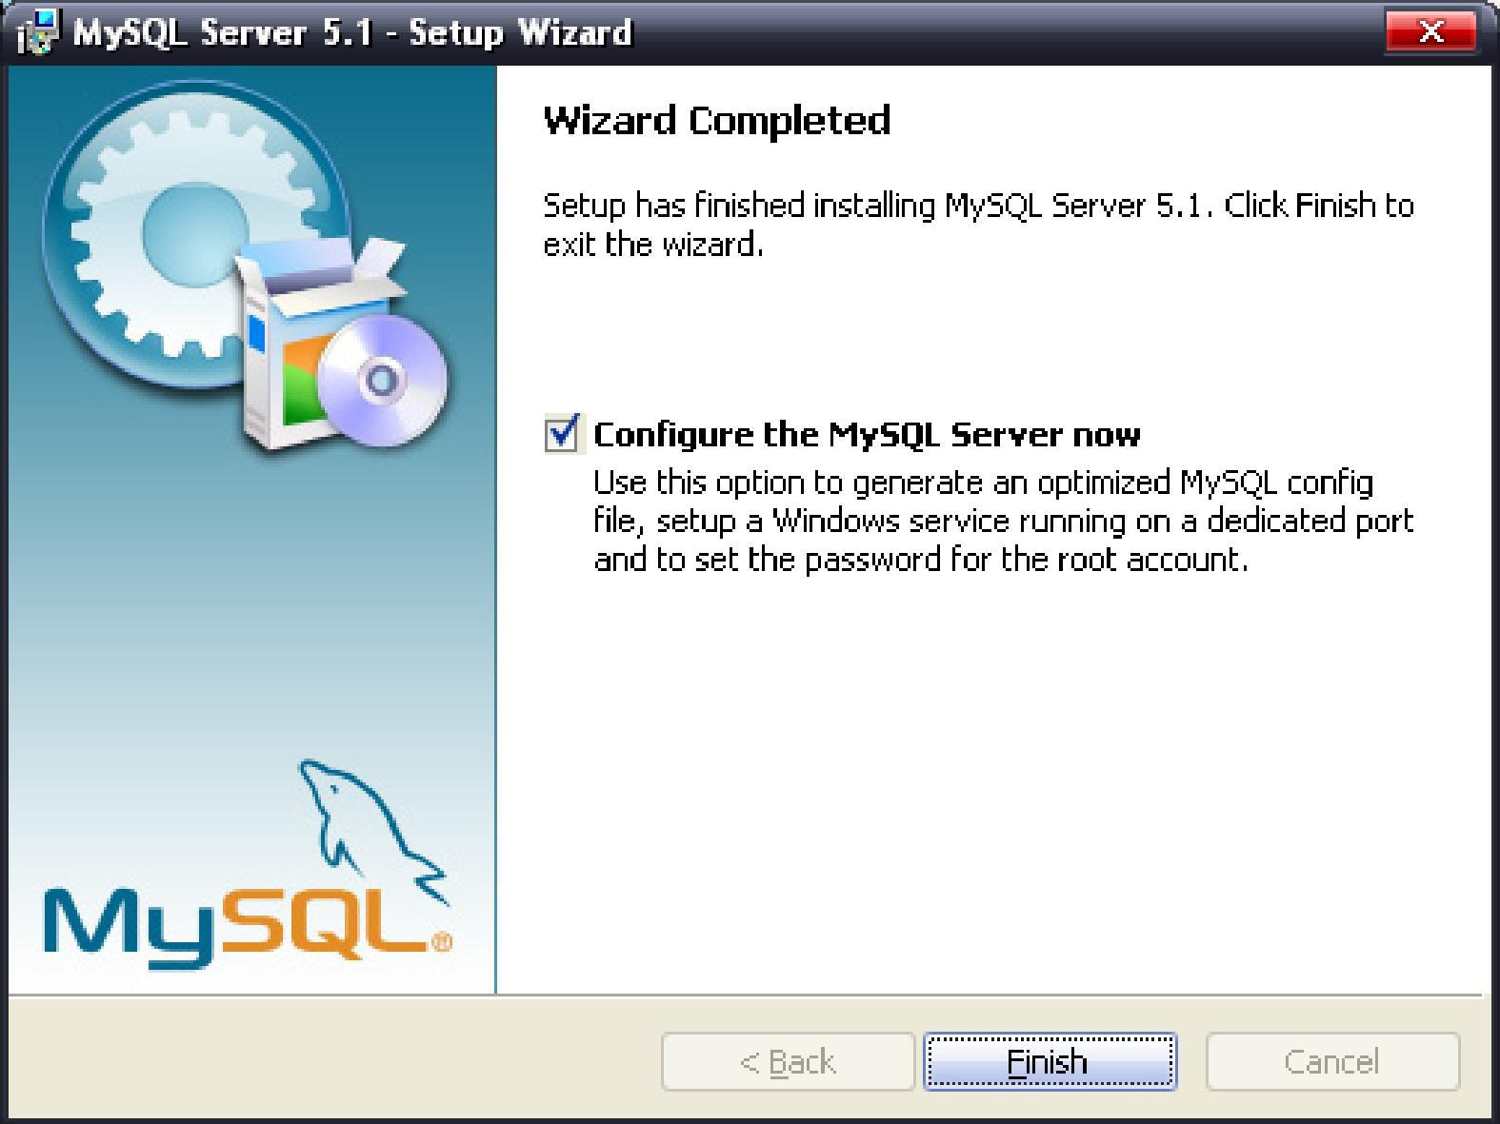
8. Choose “Configure the MySQL Server now” with checkmark “√”and click “Finish” to enter the MySQL Server instance configuration as follow picture shows. 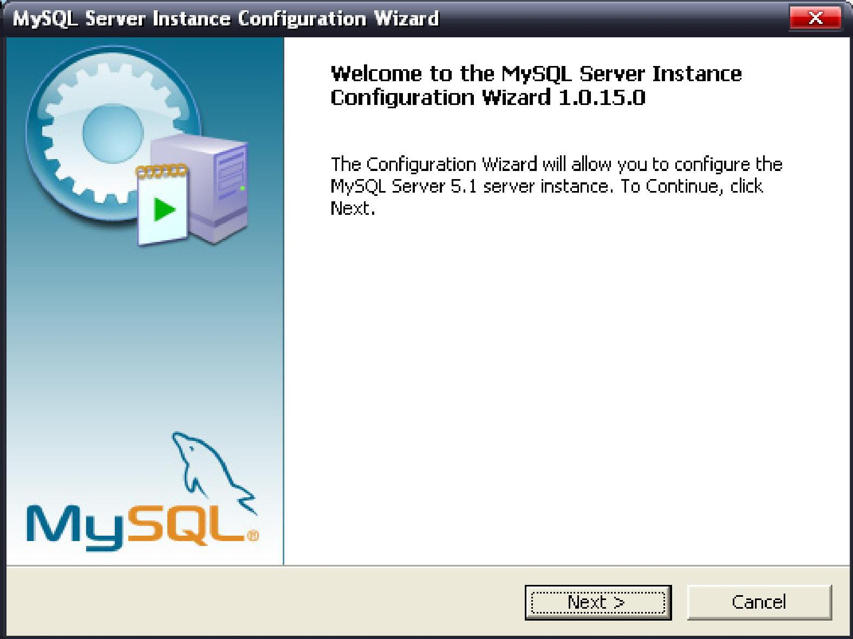
9. Click “”

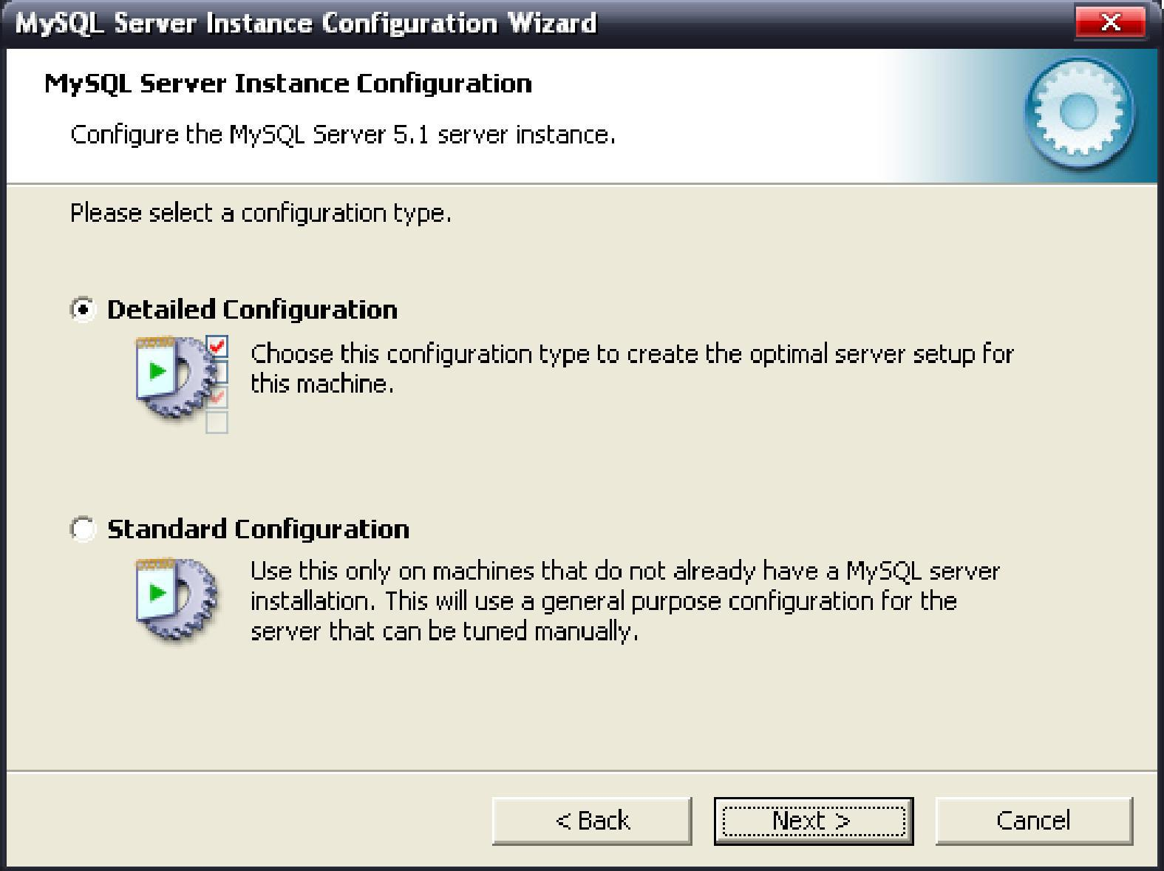
10. Select “Detail Configuration” as above picture and click “”
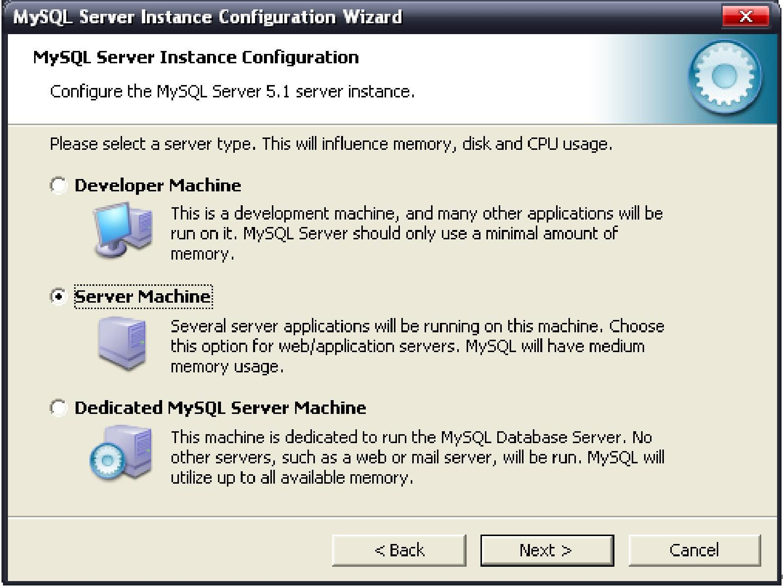
11.Click “Server Machine” as above picture and click “”to enter following picture.

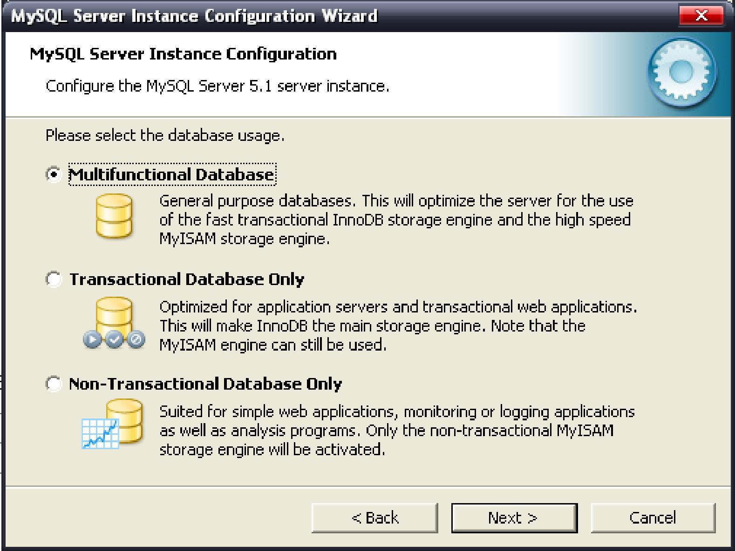
12. Click “Multifunction Database” as above picture and click “”to enter following picture.
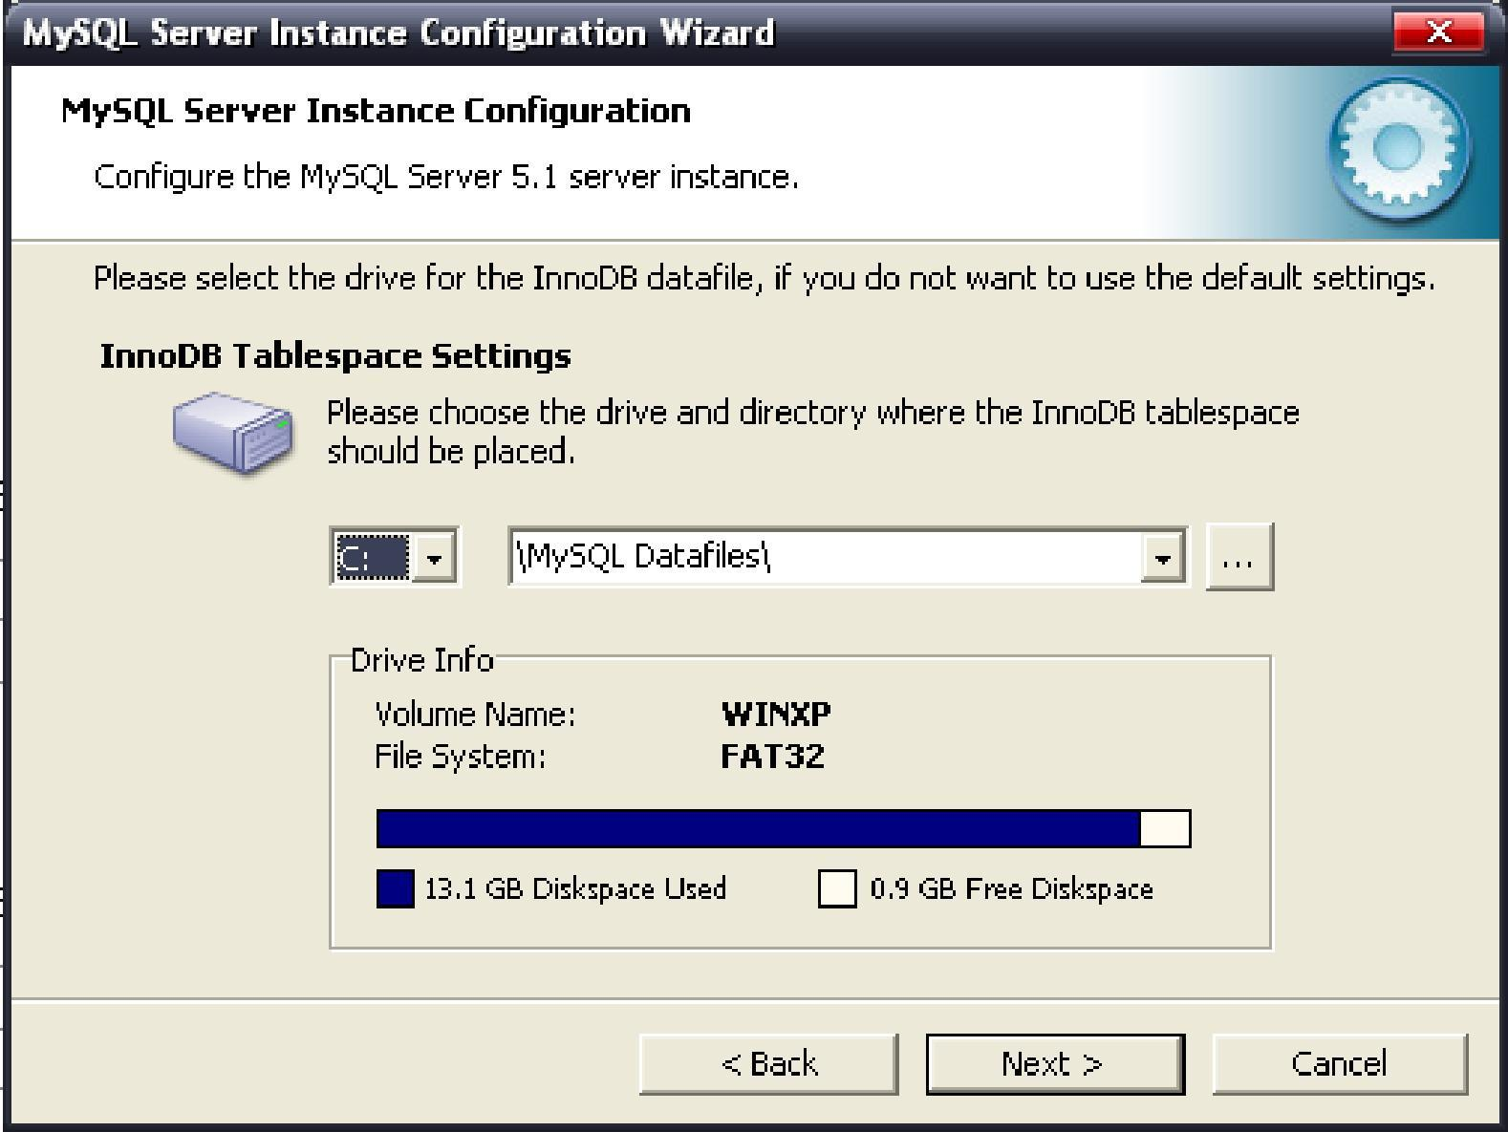
13. Click “” to go to follow picture.

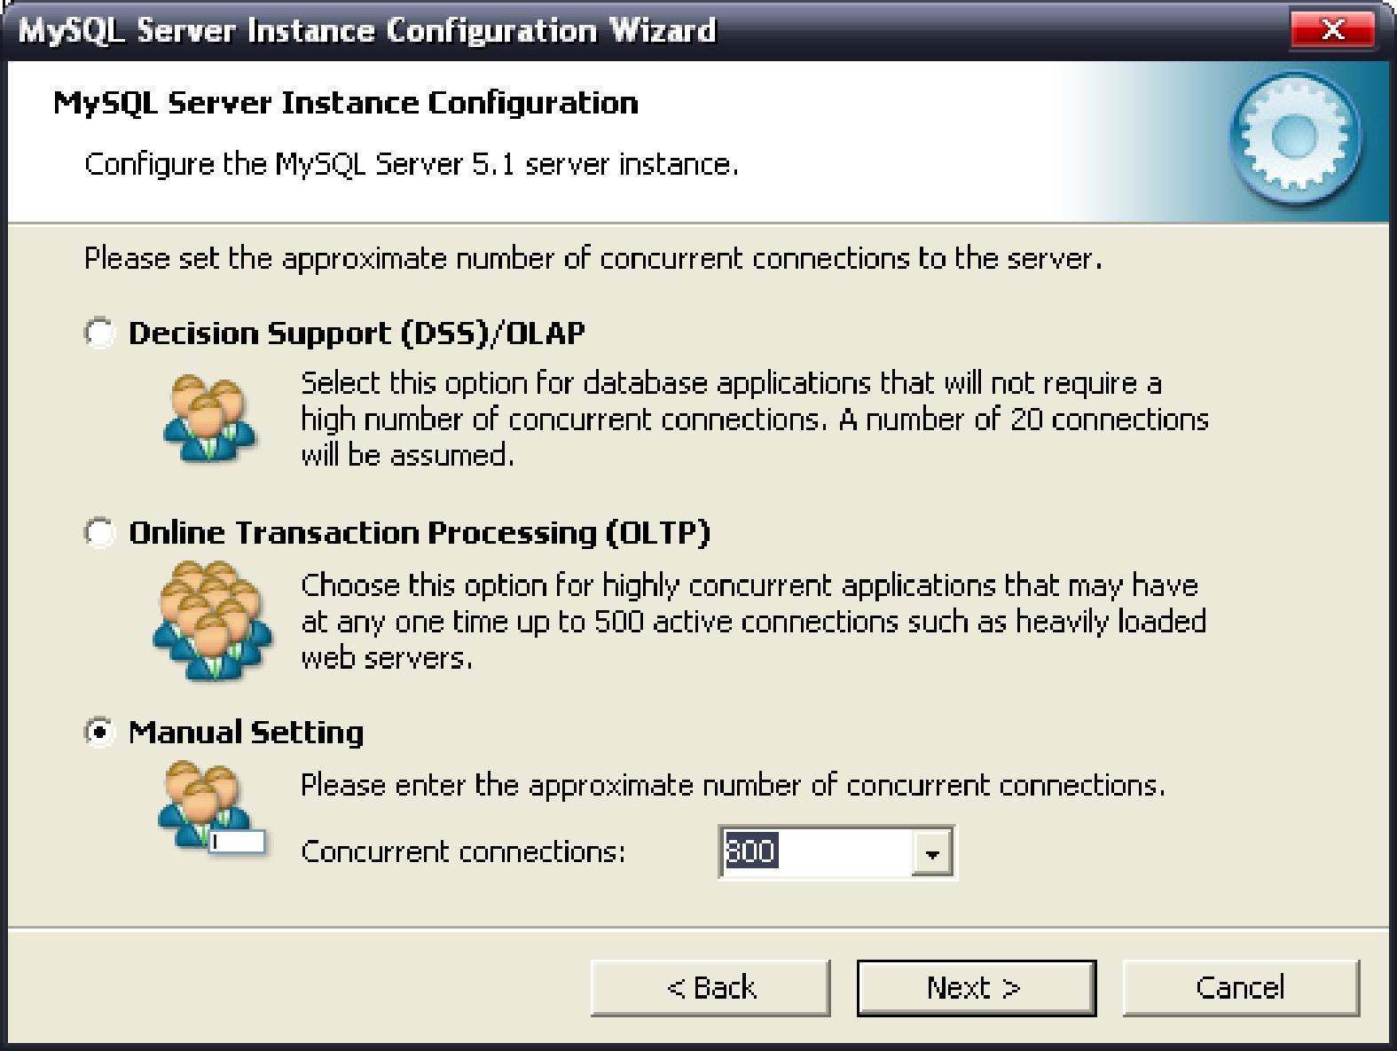
14. Choose “Manual Setting” and choose 800 in concurrent connections as above picture, then click “” to go to follow picture.
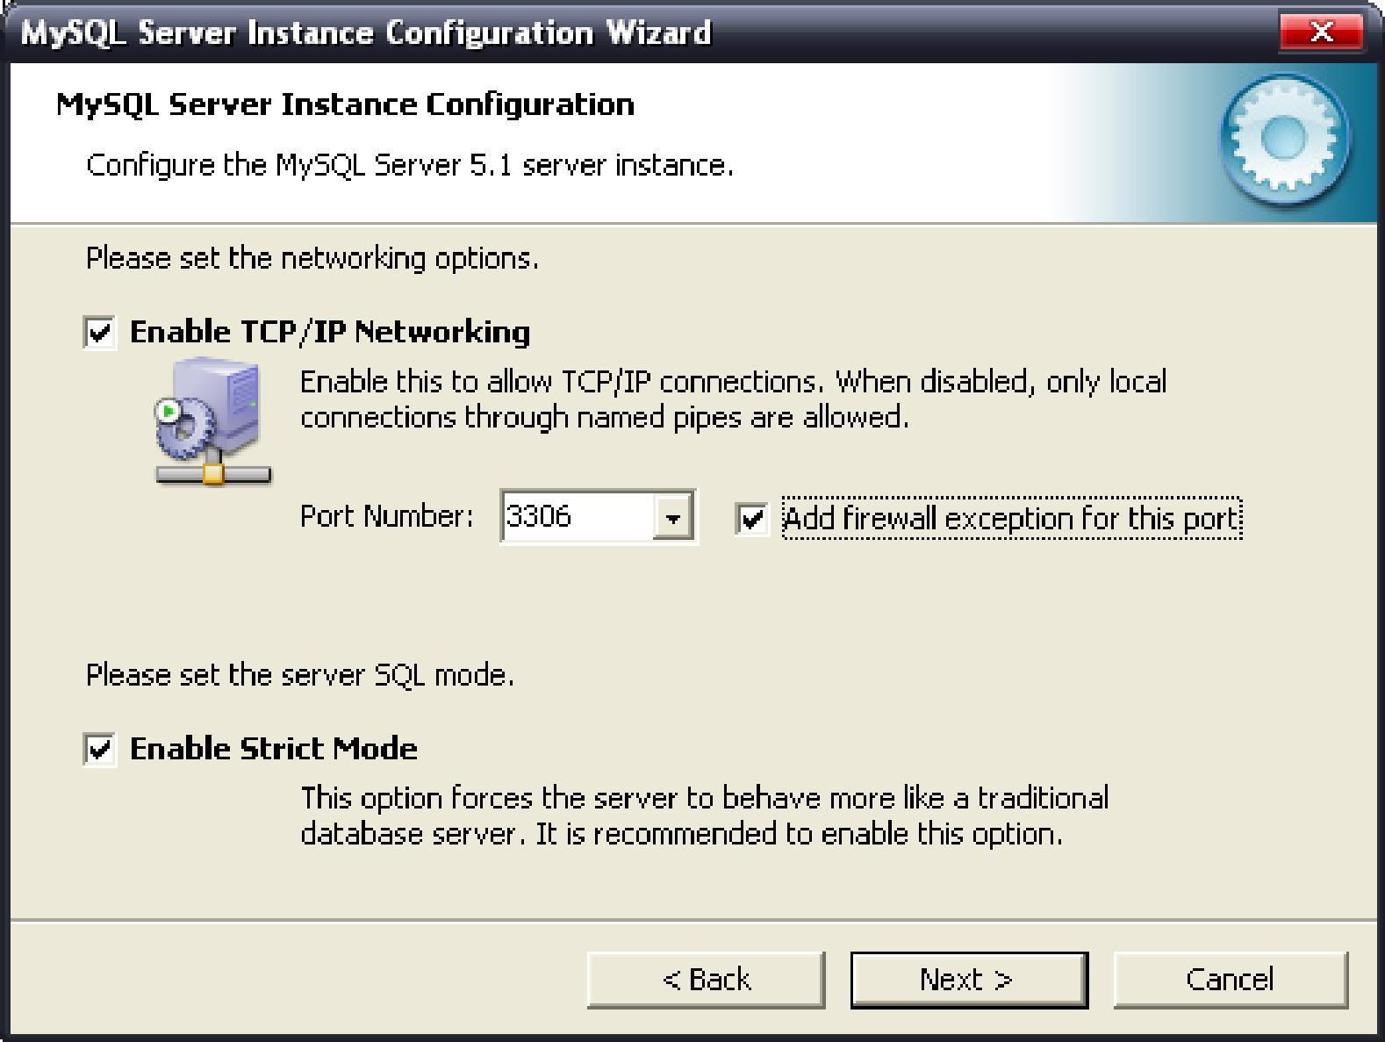
15. Select options as above picture and click “” to go to follow picture
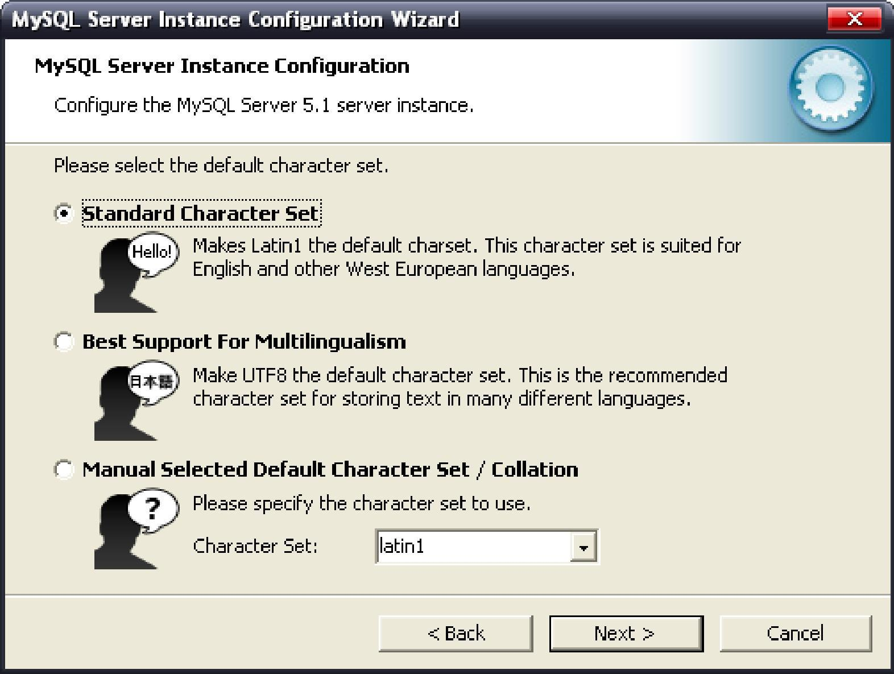
16. Select options as above picture and click “” to go to follow picture
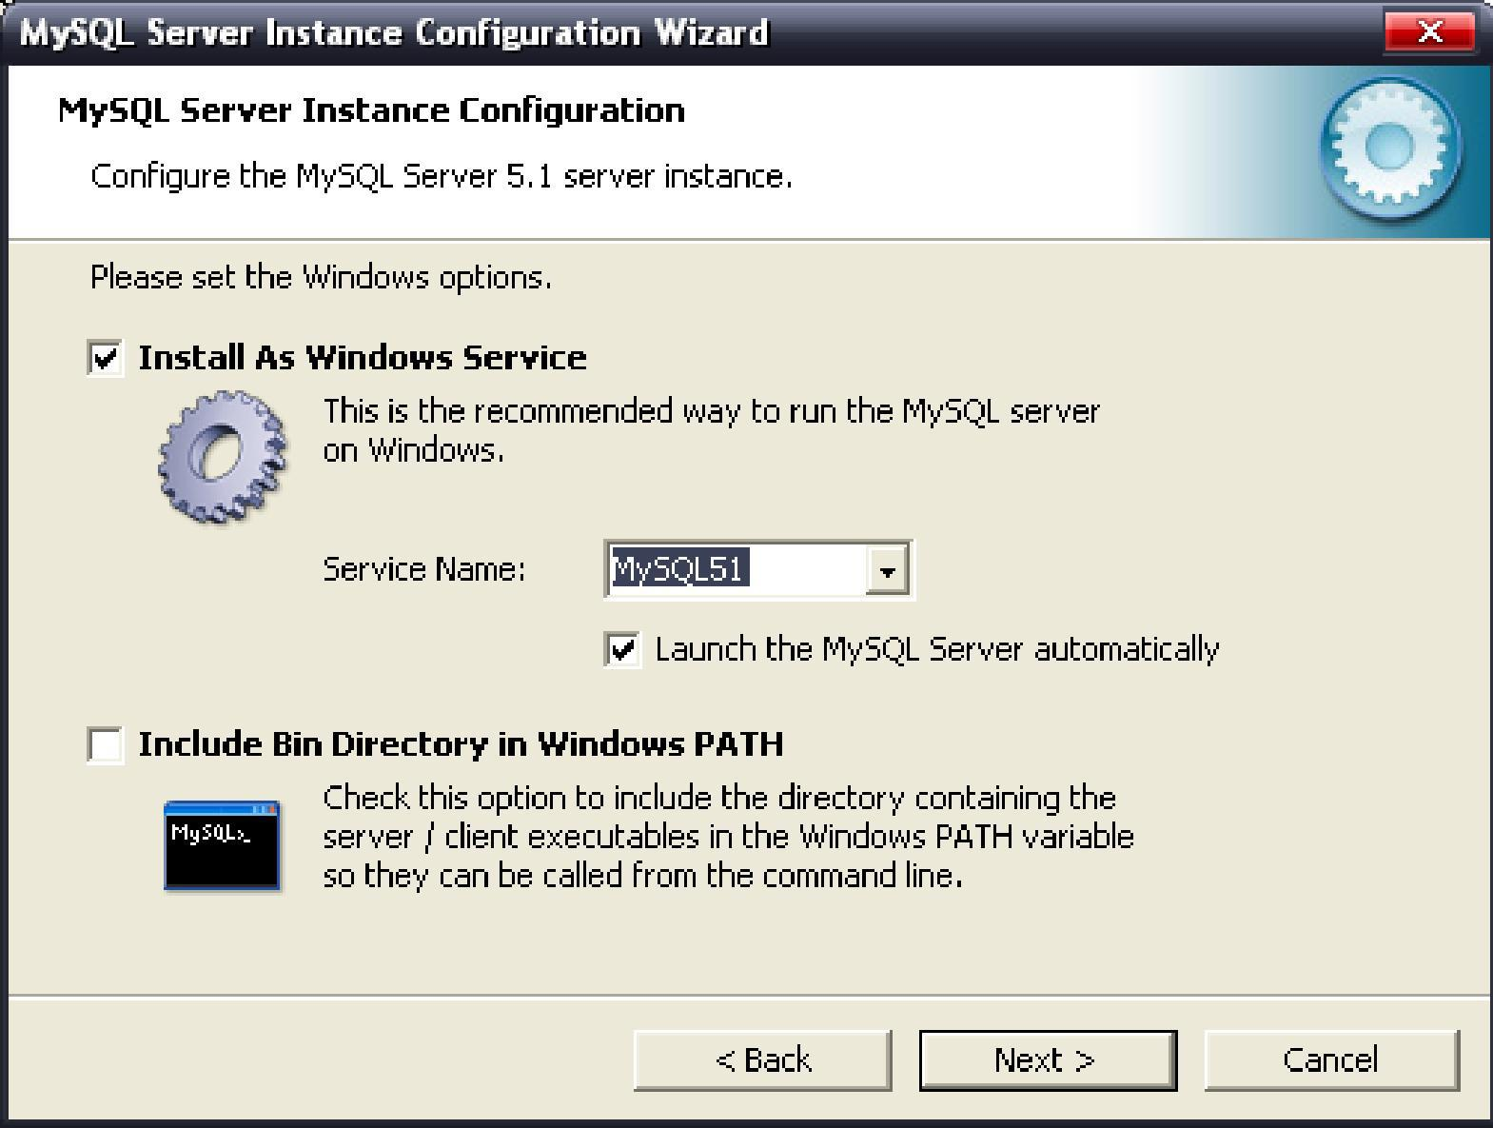
17. Select options as above picture and click “” to go to follow picture
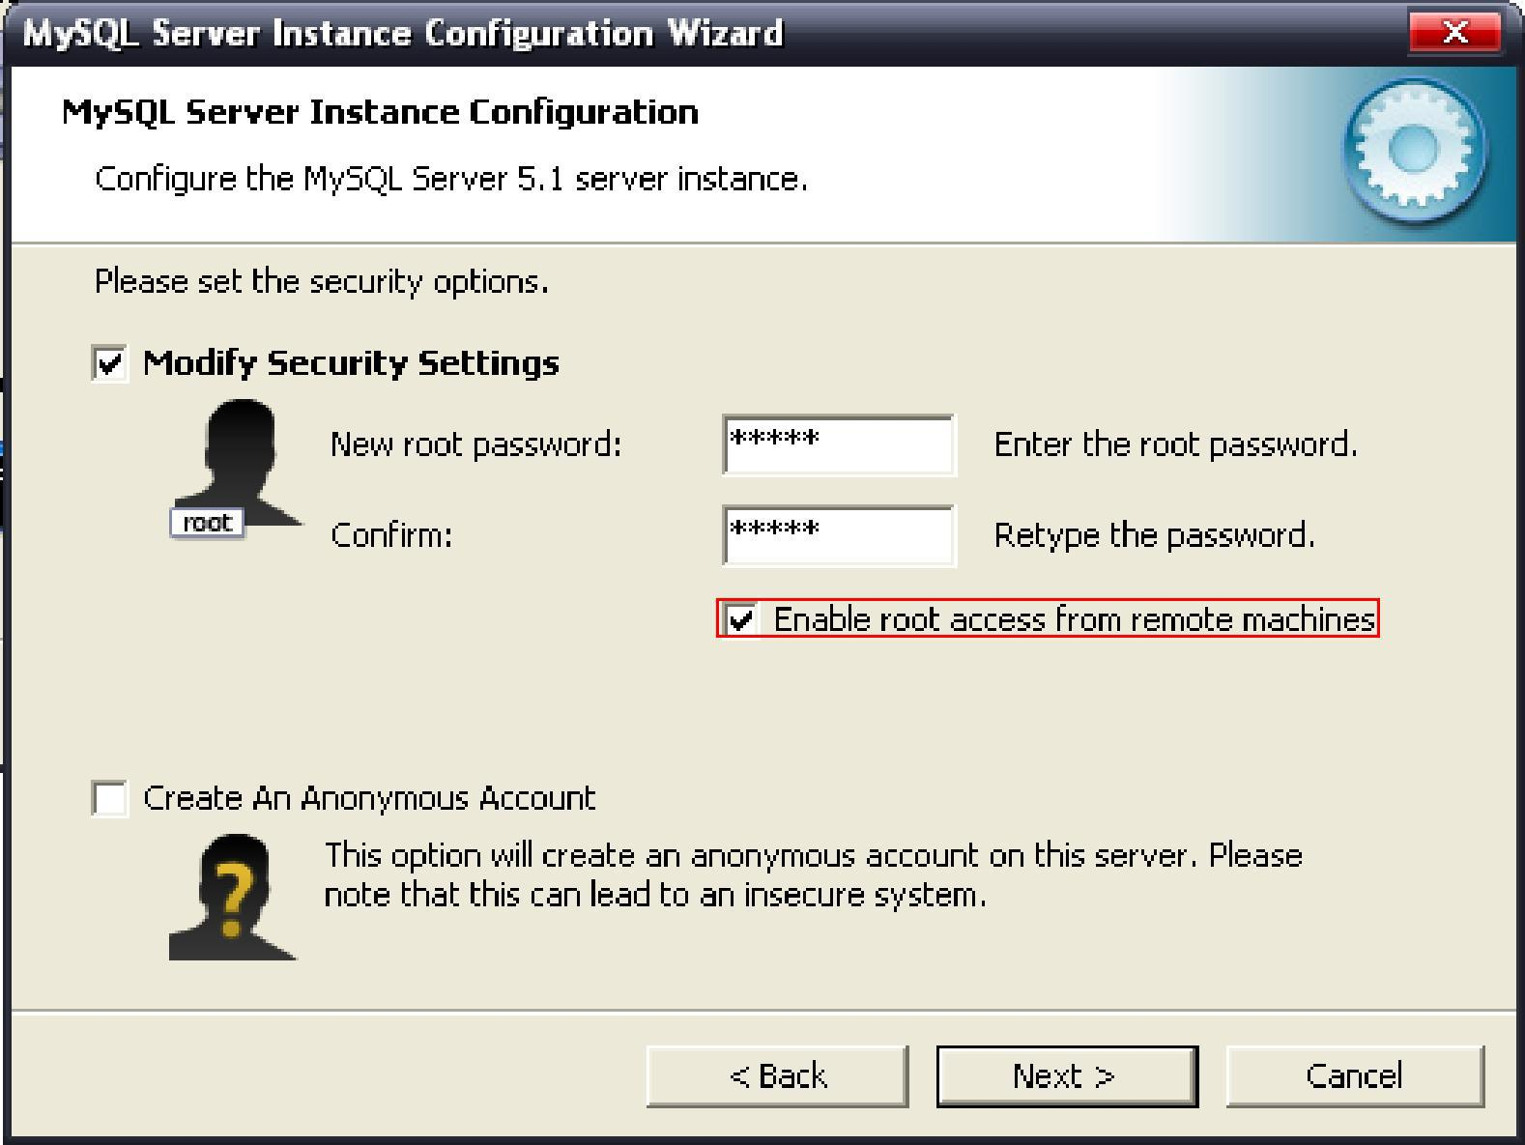
18. Select options as above picture and fill your new root password in the two edit bars. The confirm password must be the same as the new password which you filled in first edit bar. Select “Enable root access from remote machines” as above picture .You should remember the new password because the password should be the same as the password which you had to use when install NVMS.
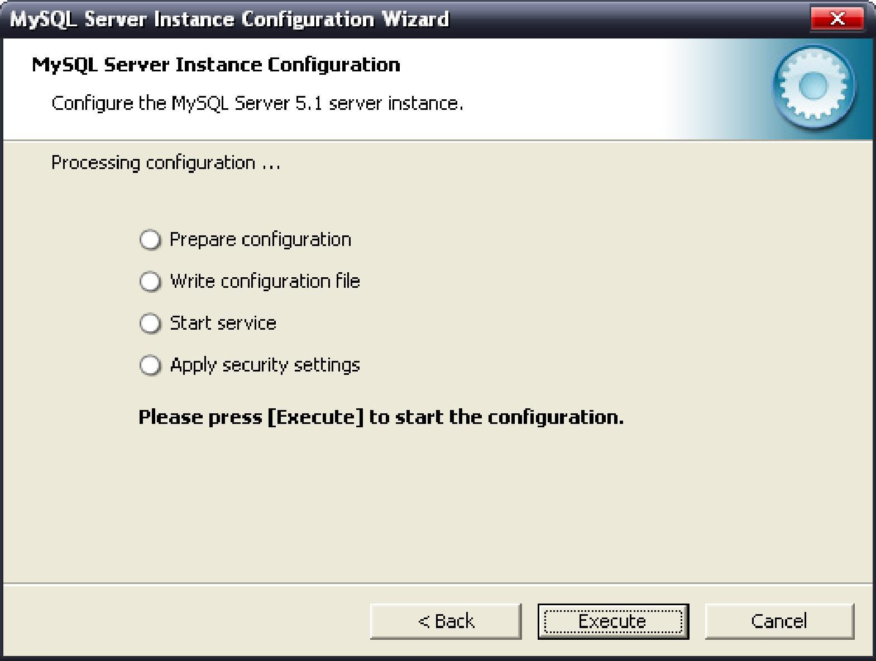
19. Click “Execute” to begin to execute relevant configuration.
If it failed to execute as follow picture shows.
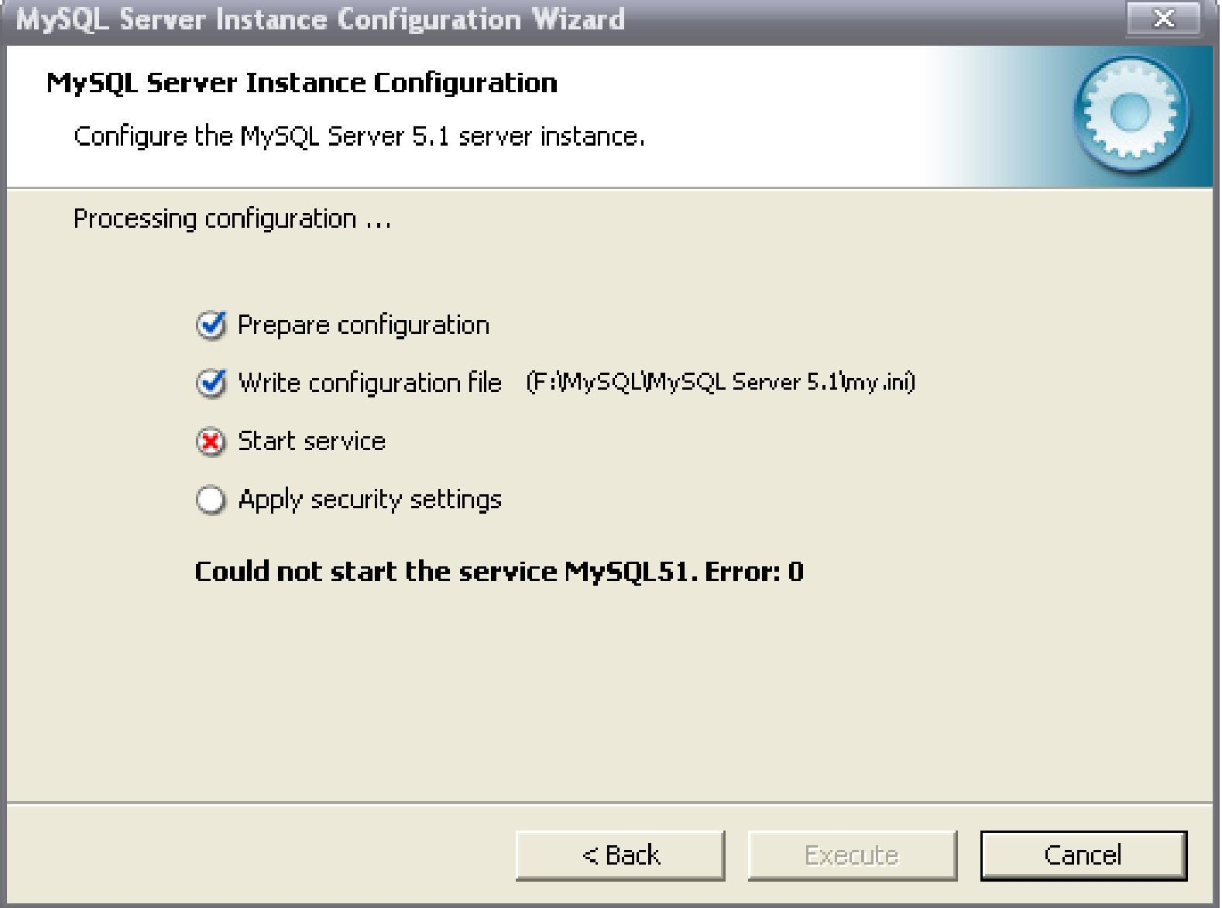
It means the MySQL which you had installed had not been deleted clearly, you can follow this steps to solve this problems.
(1)Uninstall the MySQL you had installed just now.
(2)Delete every thing in the route of “ C:\Documents and Settings\All Users\Application Data\MySQL “
(3)Install MySQL again

If it execute success, it will be showed as follow picture.
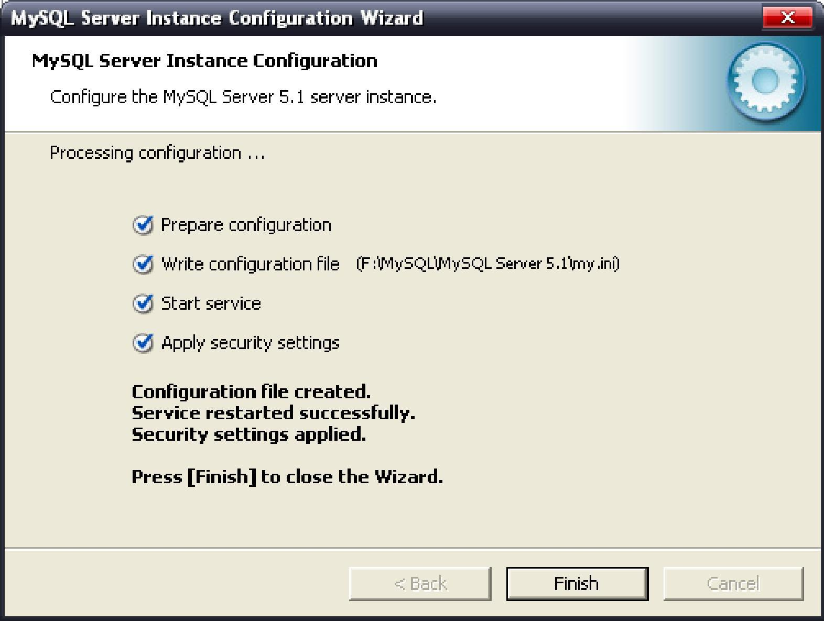

How to install NVMS?
1. After installing Mysql, you should install NVMS
There are two kinds of styles.
- Custom. Users can select server and client which he need.
- Complete. Install all of the server and client.
You can select any style according to your demand and select “”. In the following section, “Customization” will be taken as an example to introduce how to install NVMS.
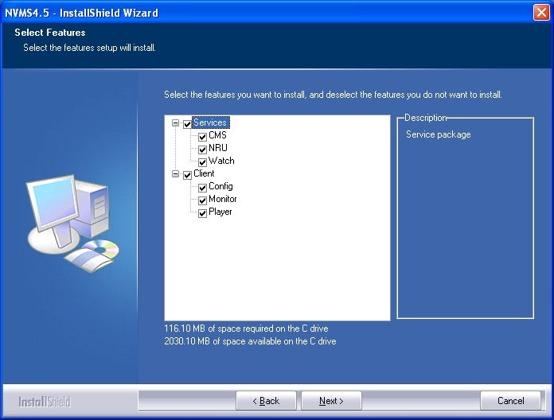
2. Select any function you need to install and click “” to start copy files.
If you select “MySQL Database”, there will be a dialog which remind you to install ODBC driver, click “” directly until finished.
3. You will begin to configure parameters after copying files.
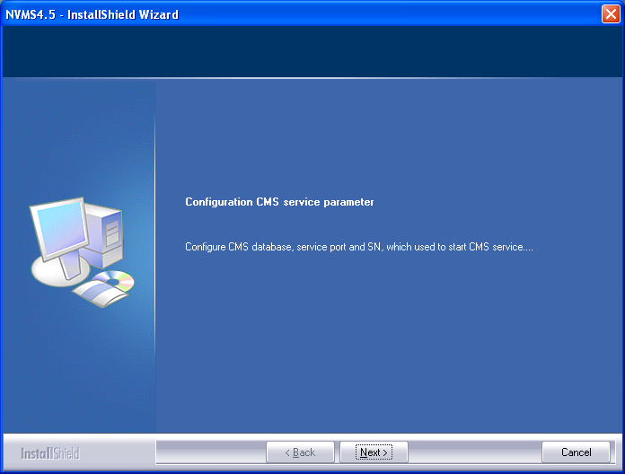

4. Click “” to start configuring relevant parameters for CMS server. Firstly please configure IP, port, username and password for Mysql database. (The password should be the same as foregone password in configuration database)
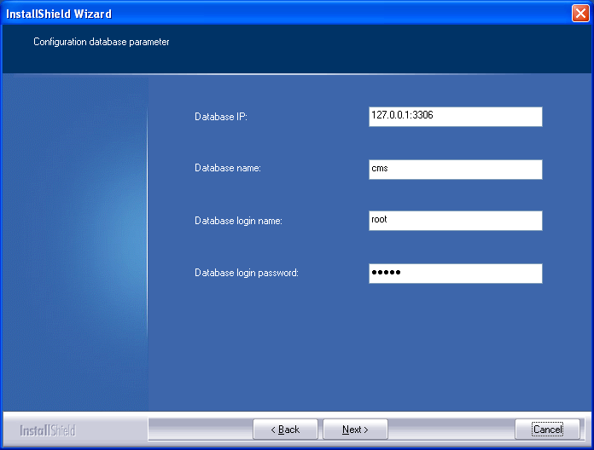In this interface, you can configure connection information for CMS database, including: IP address for database, set name for database, username and password.
If a database is used in different system, you should set different name for database. You can fill in different name directly.
If the defaulted port 3306 for Mysql had been occupied, you should change the port. You can fill in IP and changed port, for example 172.1.14.97:3386. If you install other server, you should also take attention to the problem whether the connection port had been changed, if it had been changed you should fill in your IP and changed port.
5. After configuring parameters, click”” to enter follow picture to configure ports.

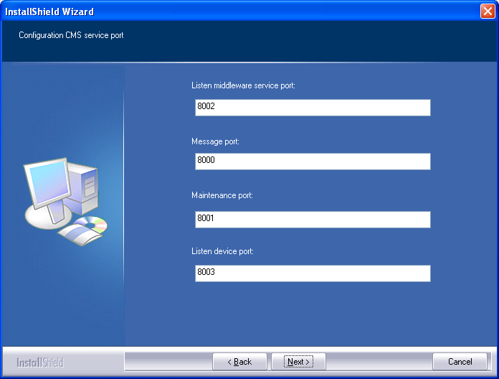
Introduction for CMS port
Listen middleware server port | Port that middleware device use to enroll to CMS such as GW, TDU, NRU and Matrix
Message port | Port that CU login CMS should use. The default is 8000.
Maintenance port | Port use to maintenance system for CMS. The default is 8001.
Listen device port | Port that DVR/S enroll to CMS should use. The default is 8003.
Please run CMD before installation to avoid port conflict with exiting program and CMS. You can input netstart-na to look up all the ports whether had been occupied. In the following picture, the contents in red case are the ports you need check. If the ports had been occupied by other program, you should input different port to avoid conflict. When you install other server, you should pay attention to it, too.

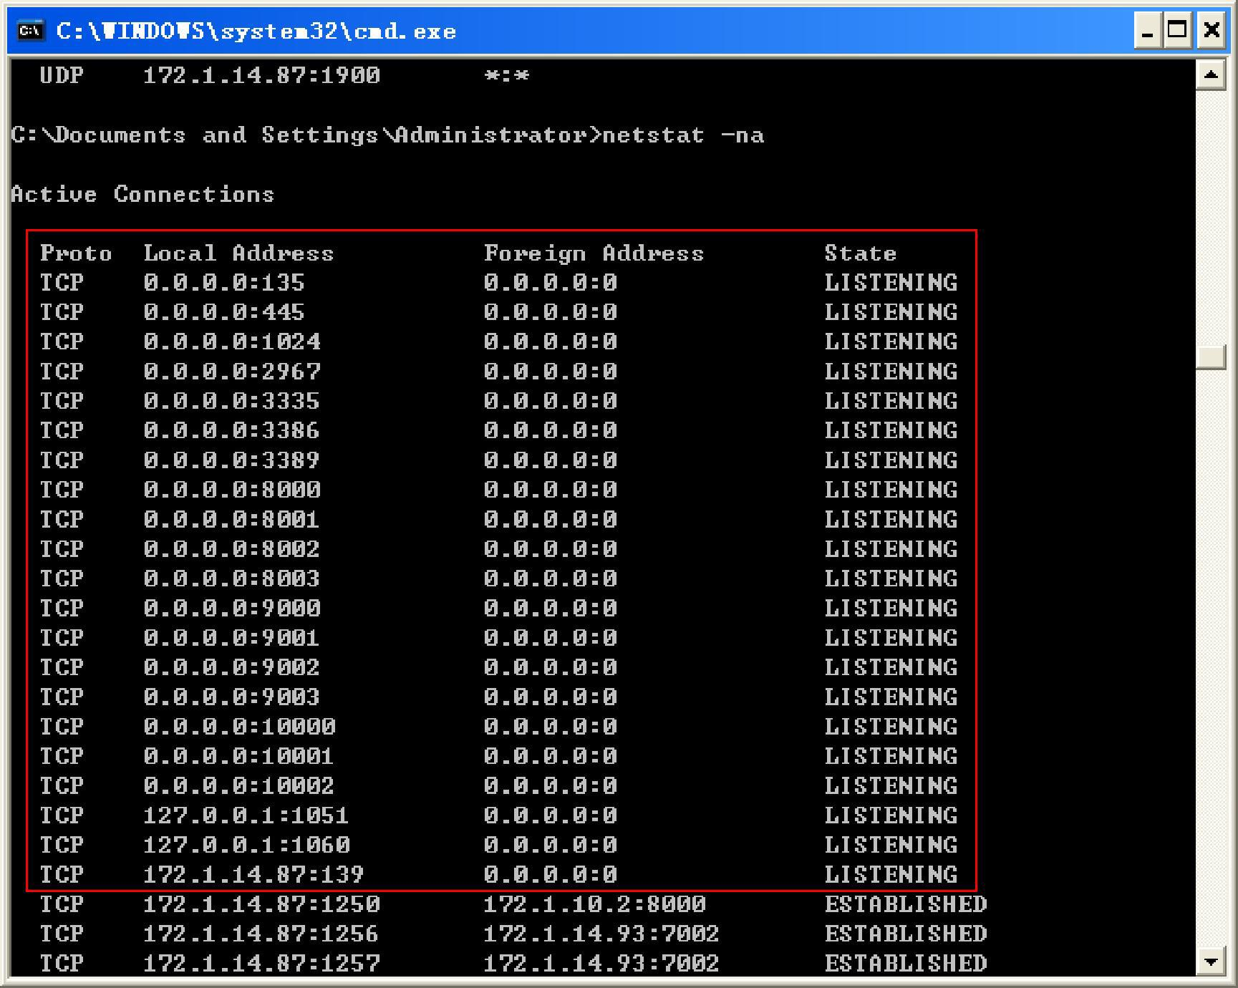
6. After configuring port click “”. In this interface, you can configure a unique identification for SN which can not be the same as other intermediate layer device.
Note；The identification is the unique identify card to identify so that it can not be repeated with others. You should be careful during setting.
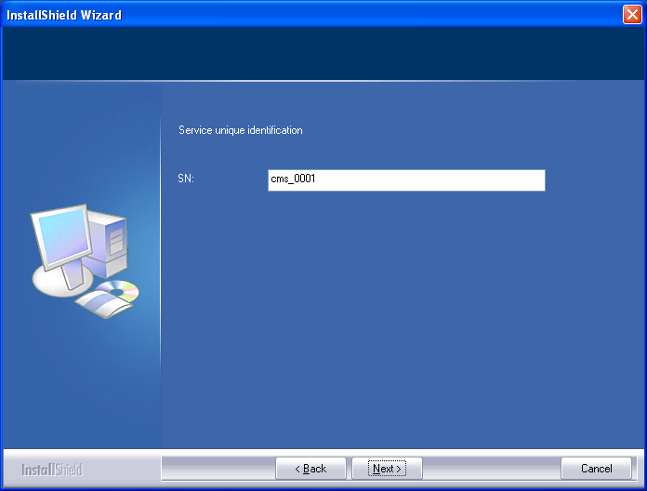
7. Please click “ “ to enter Configuration of CMS service after completion of the configuration of CMS unique identifier. After configuration, the configuration information will be written to the configuration file. And then the CMS configuration information will be stored in the installation directory (default C: \ Program Files \ NVMS \ NVMS4.5 \ Services \ bin) under the cms.cfg file.
Next you need to configure other services, the content of configuration is similar with others,
And also need to fill Mysql data connected IP, port, user name, password, and relative services, SN. Multiple services within a local area network can be connected with a Mysql database.

Select the project started immediately after installation is completes
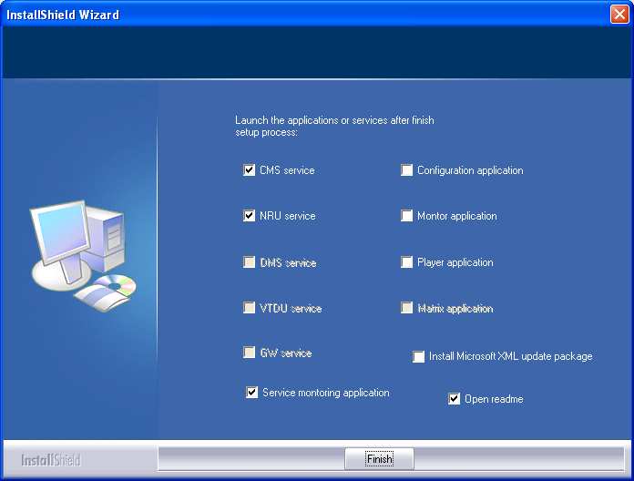
8. Select CMS and NRU service, then click finish button, The CMS and NRU service will be started automatically and then there will be two running tray on the taskbar lower right corner, It is to control CMS and NRU services, The mouse will stop at a service Tooltips and display the name of service, please refer below graphic for reference:
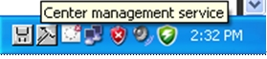

Right – click mouse on a try can stop or start this service; Click exit button can exit the tray.

If we need use the full function of NVMS, Then we need to obtain a copy of registration document named cms.lic. Please send the cms.lic info file from installation directory to product provider.
The product provider will send registered document cms.lic and to users, Please copy the registered file to installation directory and then can enjoy CMS service by normal operation. At this point, please use the tray of CMS and restart using CMS service .

Description for configuration

1. Connect database information
Database IP and port | If the service with Mysql in same PC then can fill in IP address 127.0.0.1 ( Default port is 3306) .
Database Name | Dervice was started & created database name in Mysql, Database name can not be repeated when the multiple service connect with same Mysql, suggest that database name should be in consistent with SN
Database username | Default to root
Database Password | Default to Null

2. CMS interface and SN description
Automatic-log port | Middleware device, Such as GW、VTDU、NRU、Matrix to CMS registered port, The default is 8002.
PSTN interface | CU sign-in CMS needed port. The default is 8000.
Snoop device port | DVRS device to CMS registered interface, The default is 8003.
Maintains interface | Carries on the maintenance to CMS port, The default is 8001.
SN | The identification is the unique identify card to identify so that it can not be repeated with others. You should be careful during setting.  Default is cms_0001, Need to make sure the uniqueness of SN and can not be repeated. When create the NRU equipment need to fill in this SN.
Please run CMD before installation to avoid port conflict with exiting program and CMS. You can input netstart-na to look up all the ports whether had been occupied. In the following picture, the contents in red case are the ports you need check. If the ports had been occupied by other program, you should input different port to avoid conflict. When you install other server, you should pay attention to it, too.
3. VTDU Interface and SN description
Message port | Port that used to connect CMS and VTDU can be used when created the VTDU device.  The default is 7000.
Data stream port | The port is used to transfer the distribution class media date, Default is 7002
Maintains port | The port is used to connect VTDU to Telnet to maintenance. The default is 7001.
Monitor port | If using passive mode GW, It needs to configure VTDU monitor port，such as 4455, So long as this port not inconsistent with other service port conflict then will be ok.
SN | Default is vtdu_0001. You should make sure the uniqueness of SN and can not be repeated with other SN. When create the VTDU equipment need to fill in this SN.
4. NRU port and SN description
Message port | Port that used to connect CMS and NRU can be used when created the NRU device.  The default is 10000.
Data stream port | NRU transfer the distribution class media date port, Default is 10002.
Maintains port | Carries on the maintenance to NRU port, The default is 1001 .
SN | Default is nru_001, Need to make sure the uniqueness of SN and can not be repeated.  When create the NRU equipment need to fill in this SN

5. GW port and SN description
Automatic login port | GW automatic log-on port, When CMS carries on the cascade through GW port subordinate CMS to the GW registration’s port, The default is 9002.
Message port | Port that used to connect CMS and GW can be used when created the GW device.  The default is 9000.
Data stream port | GW transfer the distribution class media date port, The dafault is 9003.
Monitor port | DVRS equipment to GW registration port , The default is 3335
Maintains port | Carries on the maintenance to GW port, The default is 9001.
SN | The default is gw00, It can be amended but need to make sure the uniqueness of SN  And can not be repeated. When create the GW equipment need to fill in this SN.
Passive connection configuration | If the GW can not be accessed by outside, it need configure passive connection information. Select passive connection, input IP address or domain for CMS, message port for CMS(The default is 8000) and automatic login port(The default is 8002 ).
6. DMS port and SN description

Message port | Port that used to connect CMS and DMS can be used when created the DMS device.  The default is 6000.
Maintains port | Carries on the maintenance to DMS PORT, The default is 6001.
SN | The default is dms_0001, It can be amended but need to make sure the uniqueness of SN and can not be repeated. When create the DMS equipment need to fill in this SN .

